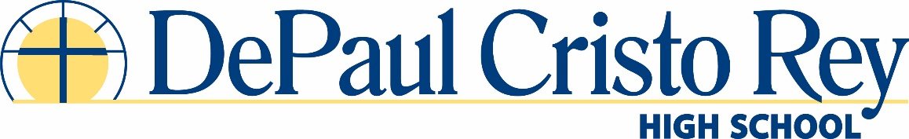
Part-time Choir Director: 2018-2019
Overview
DePaul Cristo Rey High School (DPCR) is seeking an innovative, dynamic college/school Choir Director for the 2018-2019 school year. The Choir Director will teach a choir class during the last bell of the school day and will also have two practices a week for our liturgical/show choir. The music that will be included in the curriculum will be an appropriate mix of liturgical, spiritual and popular music to be chosen by the Choir Director. Liturgical music will be selected with the guidance of the administration and Campus Ministry, as well as with input from the students.
The Director will direct and accompany choir, including:
• Four annual Masses and possibly one chapel service a month on Fridays
• Other pre-planned events where music is involved (see second sheet for full list)
- Christmas or Advent prayer service
- Catholic Schools Week
- Baccalaureate
- Graduation
• Direct choir rehearsals two days per week after school
• Play for musicals, contests, talent show, and other pre-planned needs
• Provide music charts for other instrumentalists
The Choir Director will be in charge of:
• Getting ALL music and supplies for students i.e. music, charts, folders, etc.
• Teaching Mass parts and other musical pieces
• Reporting to Director of Campus Ministry with questions/needs
• Getting all program music and lyrics to designated campus minister in a timely fashion
- Working with campus ministry team or designated planner to select music
DePaul Cristo Rey High School is a diverse and dynamic learning environment dedicated to the mission of both the Sisters of Charity and the Cristo Rey Network to bring affordable Catholic education to students who otherwise would not be able to afford a faith-based, college-preparatory learning environment. DPCR is also committed to providing an inclusive and equitable environment for students and staff.

YEAR-LONG DUTIES
1st Semester:
Welcome Back Chapel/Prayer Service 7:45-8:15 (tentative)
Founder’s Day Mass 7:45 – 9:00 a.m.
Advent Mass 9:23-10:23
DPCR Talent Show 12:00-2:00 (tentative)

2nd Semester:
Ash Wednesday Mass 1:45-2:45
Holy Week Mass TBD
Baccalaureate Mass 7:45 – 9:00 a.m.
Commencement 6:30 p.m.

