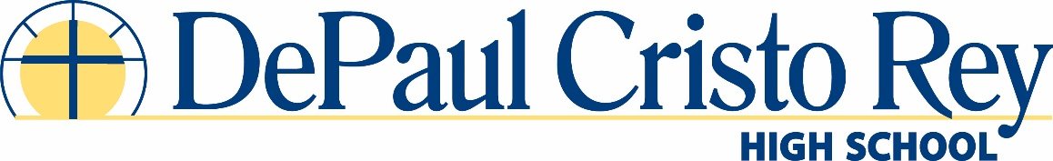
College Counseling Position
2018-2019 School year

Job Summary:

DePaul Cristo Rey High School (DPCR) is seeking an innovative, dynamic college/school counselor for the 2018-2019 school year. Counselors at DPCR guide freshmen through seniors in achieving our school-wide goal of “All students will graduate from high school AND college.” By collaboratively working with our school counseling services and academic leadership team, the successful candidate will help implement a comprehensive curriculum that provides academic counseling and social-emotional supports to our students to ensure 100 percent college acceptance to “best fit” colleges and universities.

Essential Duties

- Manage a case load of junior and senior students and lead them through the college application process.
- Share responsibilities in teaching sections of our College Readiness class to junior and senior students
- Establish working relationships across school constituencies including faculty/staff, Beech Acres counseling team, intervention specialists, Title I teachers, the Cristo Rey Network office, and our local and national university partners.
- Assist in the planning of college visits for all DPCR grade levels
- Assist in planning financial aid nights and college fairs
- Help conduct individual junior to senior year transitional meetings for students and families
- Help ensure senior students understand and complete all necessary paper-work for college enrollment i.e. FASFA verification, financial aid award letters, residential housing contracts, immunization records
- Research and coordinate opportunities like pre-college summer programs and scholarships available to our students
- Assist academic assistant principal in monitoring and intervening with students “at risk” academically
- Other duties as assigned

Qualifications

• Master’s degree in School Counseling, Higher Education Administration or related discipline
• Two to three years post-graduate work experience
• Teaching experience in a k-12 or higher education setting
• Strong communication, time management, and organizational skills
• A collaborative team approach
• Experience with student information management systems and learning management systems
• Experience working with diverse student populations

DePaul Cristo Rey High School is a diverse and dynamic learning environment dedicated to the mission of both the Sisters of Charity and the Cristo Rey Network to bring affordable Catholic education to students who otherwise would not be able to afford a faith-based, college-preparatory learning environment. DPCR is also committed to providing an inclusive and equitable environment for students and staff.

